**SEND ASSETS REQUEST**  
This page allows users to submit asset requests for branches. The request form requires the following fields to be completed:

* **Creator**
* **Branch**
* **Address**
* **Contact Person Name**
* **Contact Person Number**
* **Required Assets** (e.g., Computer/Laptop, Printer, Mouse, Scanner, Keyboard, Morphon Devices)

Users can add additional asset requests by clicking the (+) icon or remove an entry using the delete icon. Once the request details are filled out, users can submit the form. Upon submission, the request is forwarded to the EVP (Executive Vice President) for approval.

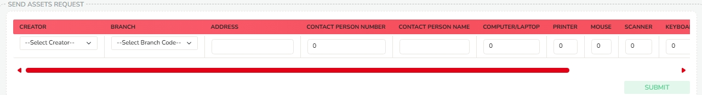

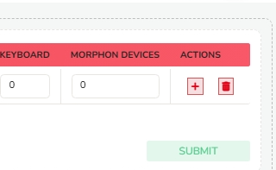

**EVP ASSET REQUEST APPROVAL**

This page allows the Executive Vice President (EVP) to review and approve asset requests submitted by branches. Upon accessing the page, the EVP will see a table displaying the following details for each request:

* Serial Number
* Creator
* Branch
* Branch Address
* Phone
* Contact Name
* Requested Assets (Computer/Laptop, Printer, Mouse, Keyboard, Morphon Devices)
* Status

In the **Status** column, a checkbox is provided, allowing the EVP to approve each asset request by ticking the box. Once approved, the request is forwarded to the Admin for final approval.

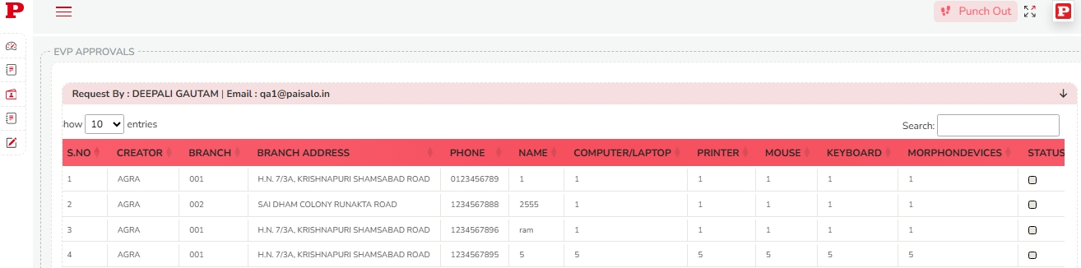

**ADMIN ASSET REQUEST APPROVAL**  
This page is used by the Admin to approve asset requests received from branches. The page displays a table with the following key details for each request:

* **Approved By**
* **Requested By**
* **Email Address**

The table includes the following columns:

* Serial Number
* Creator
* Branch Address
* Phone
* Contact Name
* Requested Assets (Computer/Laptop, Printer, Mouse, Keyboard, Morphon Devices)

In the **Status** column, there is a checkbox that allows the Admin to approve the request. After ticking the box, the Admin can click the **Approve** button to approve the asset request.

